\
[CS250]-Operating System Spring : 2021-22 Homework: 03
Name: Pravin Arjun Shankhapal Roll No: 12041130 Email:pravinarjun@iitbhilai.ac.in

PART A:

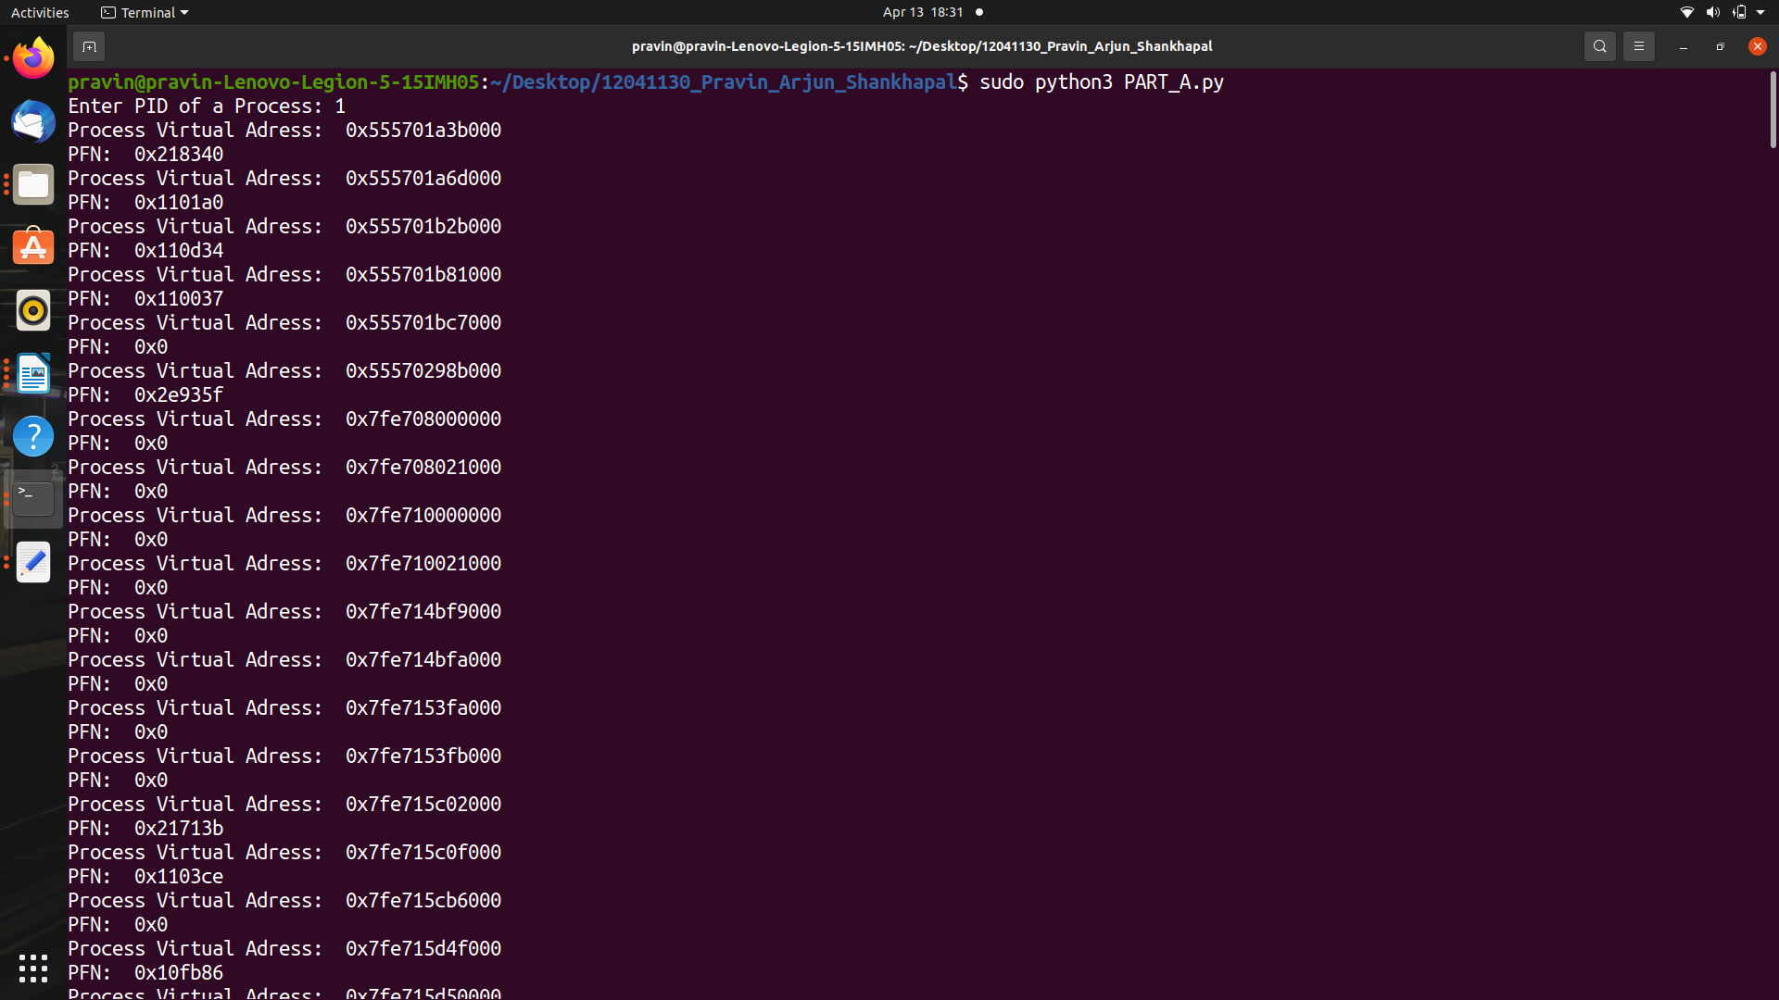

In part A priting all page frame numbers and process virtual adress.
Calculate the offset. Get the first 54 bits of PFN from the extracted PTE using offset.

PART B:

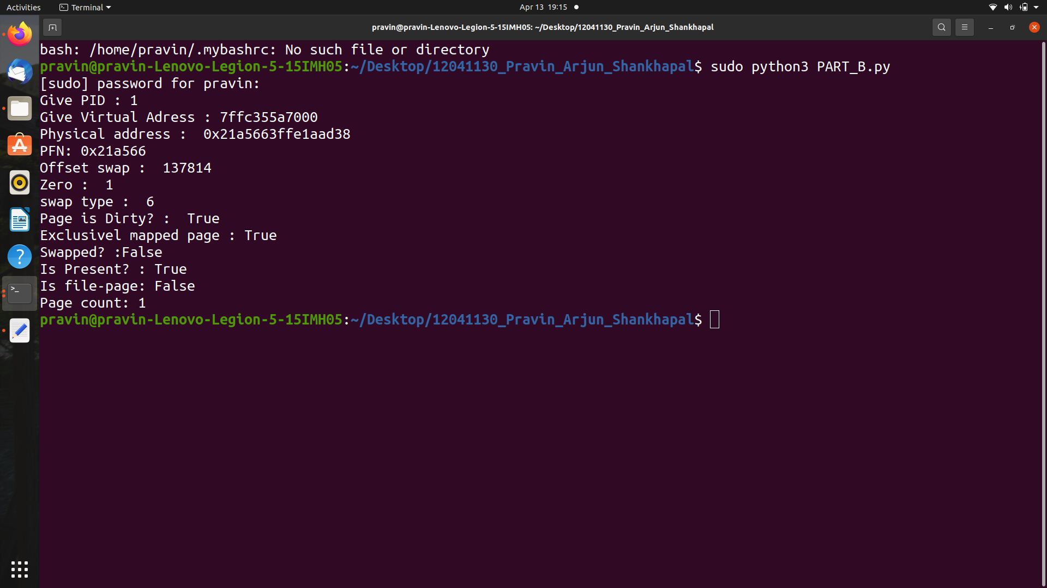

Built the extra functions for calculating PFN, type and offset of swap, soft dirty, file page, page swapped, zero, page present, page count.
We calculated this from bits 0-63.

PART C:

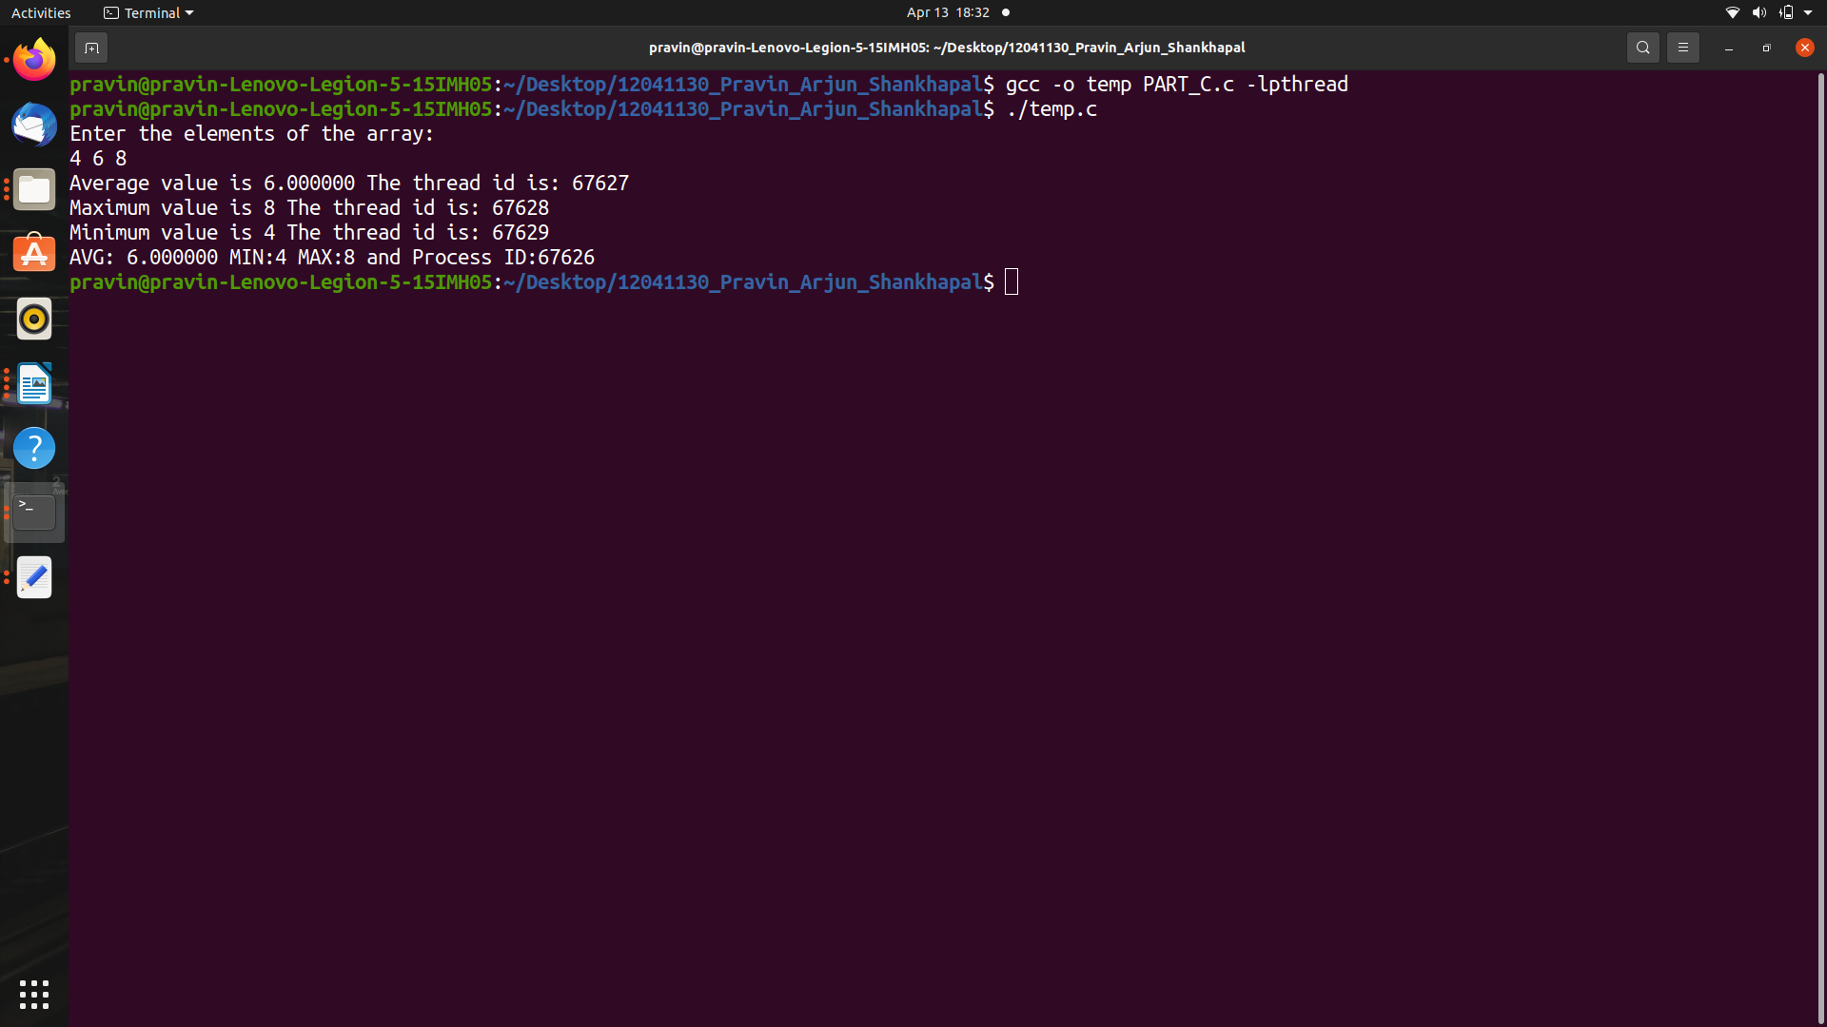

Created thread which calculates average, minimum, maximum of the given input.

